Museum Without Walls

I Dreamed a Dream the Other Night

Curator: Elif Kamışlı

2017
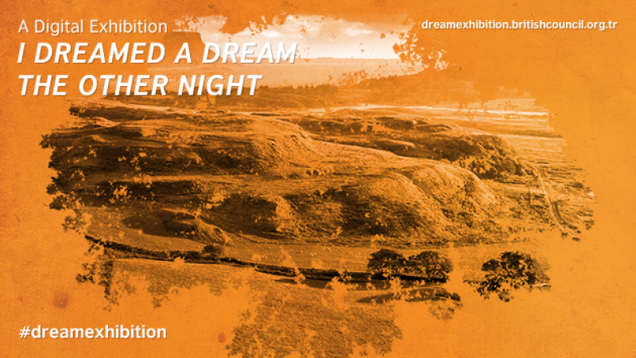

The exhibition focused on two strong traditions in British art: landscape painting and sculpture.

Artists
Vanessa Bell, David Muirhead Bone, Eveleen Buckton, Charles Cheston, Duncan Grant, Wilfred Fairclough, Richard Long, Paul Nash, Susan Philipsz, Gwendolen Raverat, Philip Wilson Steer, Alfred Thornton.

Curator
Elif Kamışlı

Curatorial text
This exhibition was born from a simple curiosity: how do people in different periods of time connect with nature when faced with a feeling of ephemerality, either as a result of the profound changes surrounding them or due to an idiosyncratic questioning of the relationship between loss and time? The beauty embedded in nature rests on her simple yet powerful harmony that persists despite all the disasters with which she is faced. Bombs fall, loved ones pass away and yet rivers continue to flow and flowers to blossom with every breaking day, as if nothing has happened. Much like a resilient hero always capable of moving forward with their adventures, nature reminds us of the urge to stand still even if the world falls apart. Maurice Blanchot started his book ‘The Writing of the Disaster’ (1980) with these words: ‘The disaster ruins everything, all the while leaving everything intact. It does not touch anyone in particular; ‘I’ am not threatened by it, but spared, left aside. (…) We are on the edge of disaster without being able to situate it in the future: it is rather always already past, and yet we are on the edge or under the threat, all formulations which would imply the future…’ I Dreamed A Dream The Other Night invites its visitors to contemplate on the ideas of ‘timelessness’ and ‘disasters’ while reinterpreting nature as a shelter for vulnerable souls in a moment where past dissolves into future and future dissolves into today.
The exhibition begins with a series of landscape drawings, a painting and an etching produced by artists who were born into a transition period when humanity in the West witnessed dramatic changes. The rise of industrial machines, the extoling of science and consequent questioning of religion, as well as the determined belief in constant progress, trapped the souls of ordinary people in a hopeless stillness. The artists featured in the exhibition were wandering in nature, haunted by the destruction of world wars as their brushstrokes depicted flourishing green life. Despite the storms in their souls, they walked on lands and sought for hope in green hills, colourful flowers, dark trees and snowy mountains. Presented on the walls surrounding the exhibition space, these beautiful works create an invisible shield inviting visitors to re-consider landscape as a response to materialism and to contemplate how these artists turned to nature for solace and inspiration in a moment of mass destruction and social transformation. This section includes the works by Vanessa Bell, David Muirhead Bone, Eveleen Buckton, Charles Cheston, Duncan Grant, Wilfred Fairclough, Paul Nash, Gwendolen Raverat, Philip Wilson Steer and Alfred Thornton.
Richard Long’s sculptural installations indicate a significant exploration which brings a new interpretation to the relationship between land and nature in his artistic practice that now spans almost half a century. His works represent the basic forms of nature with collected materials during his walking routes and gives a glimpse of his relationship between time and place. With ‘Spring Circle’ (1992), Long marks a walk-through north Cornwall by arranging chunks of greenish-blue slate in a circle on the floor. His physical traces on land are destined to disappear in a short period of time, however an aura derived from his knowledge and memories infuses his sculptures and wall drawings. Long’s act of walking as a graceful gesture seeks a harmony with the universe; walking as a meditative, personal and un-recordable exercise in the slowness of time finds an embodiment in the exhibition space through his inimitable style.
For her sculpture in sound ‘Lowlands’ (2008), Susan Philipsz recorded three versions of ‘Lowlands Away’ – a Scottish lament about a man drowned at sea who returns to tell his lover of his death. As if it were a spirit on a journey from 5 centuries ago, this work fills the exhibition space; it creates invisible bonds between the other works and attempts to drag the visitors into a dreamy land where impossible becomes possible and all disasters eventually disappear. Philipsz’s untrained and unaccompanied voice creates an intimacy while the lyrics give a powerful feeling of nostalgia. ‘Lowlands’ becomes the essence of this exhibition which hopes to create a constellation of different souls who are troubled with the same questions about nature.

Artwork list (All artworks are from the British Council Collection)
- Alfred Thornton, Early Dawn Near Gibraltar, not dated, Watercolour on paper, 21.3 x 27.6 cm
- Charles Cheston, Dorset Landscape with Quarry, 1918, Ink and pencil on paper,
- 24.5 x 37.5 cm, © The Artist's Estate
- Charles Cheston, Norton Malrewood, 1923, Ink and wash on paper, 25 x 37 cm © The Artist's Estate
- Duncan Grant, Mount Caburn, 1948, Oil on panel, 41 x 59 cm © Estate of Duncan Grant. All rights reserved, DACS 2017
- David Muirhead Bone, River in Castile, not dated, Watercolour and crayon, 27.94 x 45.4 cm, © Estate of Sir Muirhead Bone. All Rights Reserved, DACS 2017
- Eveleen Buckton, Nant Gwynant, 1943, Aquatint, 33 x 21.5 cm, © The Artist's Estate
- Eveleen Buckton, Near Bala, North Wales, 1940, Watercolour, 16.5 x 25.5 cm, © The Artist's Estate
- Eveleen Buckton, Tyinsholmen, Norway, 1946, Watercolour and ink of paper, 26.6 x 35.5 cm © The Artist's Estate
- Gwendolen Raverat, Winter Morning, not dated, Colour wood cut, 14.8 x 19 cm © Estate of Gwen Raverat. All rights reserved, DACS 2017
- Paul Nash, Stone Cliff, 1921, Watercolour on paper, 38 x 55 cm
- Philip Wilson Steer, Low Tide, Mill Beach, 1933, Watercolour on paper, 23 x 31 cm
- Philip Wilson Steer, Morning Landscape, with Trees, 1924, Watercolour on paper, 22 x 32 cm
- Philip Wilson Steer, Sky Study at Greenhithe, 1932, Watercolour on paper, 21.5 x 28.5 cm
- Philip Wilson Steer, Stormy Sky, Whitstable, 1931, Watercolour on paper, 23 x 31 cm
- Richard Long, Spring Circle, 1992, Delabole slate 300 cm diameter. The work was digitally modelled for this project with the artist’s permission.
- Susan Philipsz, Lowlands, 2008, Three-channel sound installation, 8 minutes, 30 seconds. The work was digitally installed for this project with the artist’s permission.
- Vanessa Bell, Flowers in the Window, 1934, Watercolour on paper, 51 x 31.6 cm © 1961 Estate of Vanessa Bell, courtesy Henrietta Garnett
- Wilfred Fairclough, Mountains Near Innsbruck, 1937, Pencil, ink and watercolour on paper, 21.9 x 28.5 cm © The Artist's Estate

Awards
Golden Spider Awards:
- Best Website of the Year
- Best Microsite
- Best Culture and Arts Website
- Best Mobile Website

Project team
Project Manager: Su Başbuğu, British Council
Project Advisors: Esra A. Aysun, British Council, Emma Dexter, British Council, E. Osman Erden, Mimar Sinan Fine Art University
Communications: Merve Aydoğan, Cenk Cengiz, Özlem Ergun, Meltem Günyüzlü Ateş, Didem Yalın Kurel, British Council
British Council Collection: Nicola Heald, Katrina Schwarz
Voice over: Elif Kamışlı (TUR), Catherine Sinclair-Jones (ENG)
Web Design and development: Pompaa

Screenshots from exhibition website
